Christopher Lunsford
CS-255
June 28, 2026
System Design Document

UML Diagrams

UML Use Case Diagram
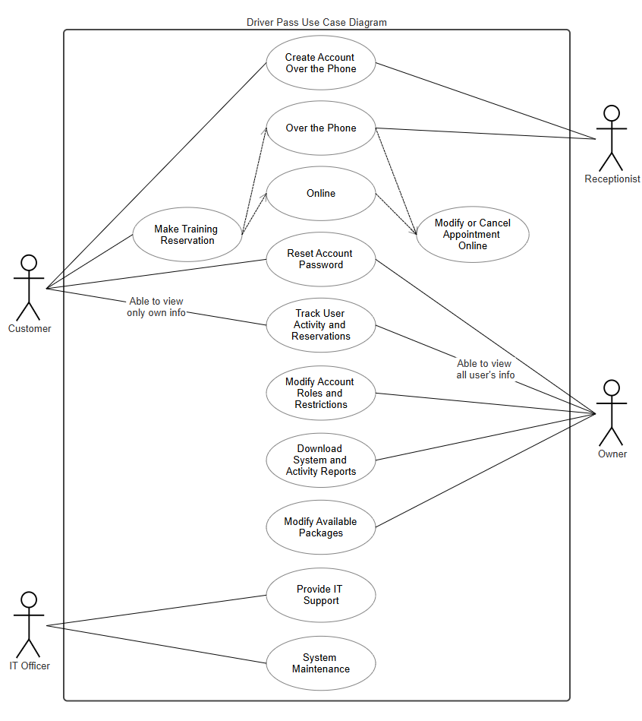

UML Activity Diagrams
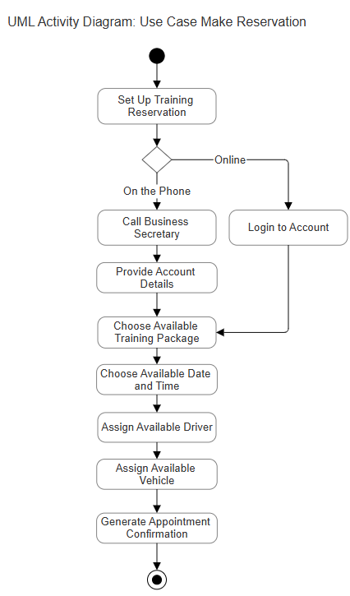
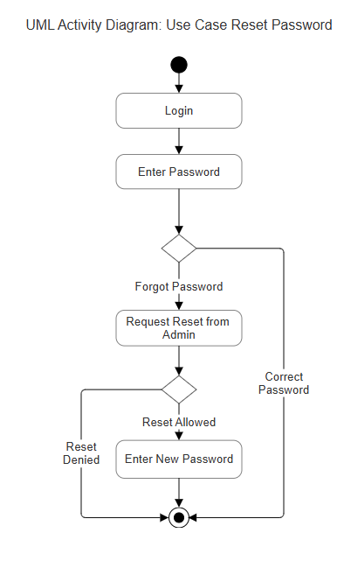

UML Sequence Diagram
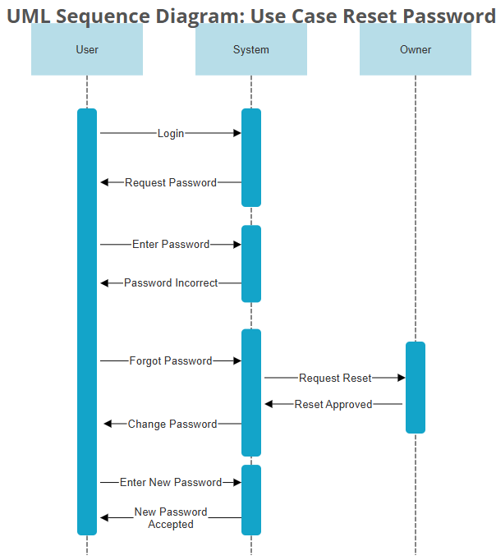

UML Class Diagram
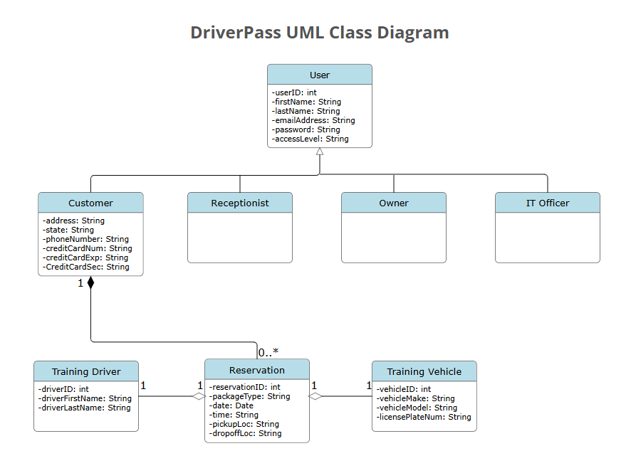

Technical Requirements
Hardware
Users who wish to make use of the DriverPass app will need to have access to a PC, laptop, or mobile device which is capable of accessing the internet. For the back end of development, the DriverPass system will require high-capacity storage servers which can be accessed over the internet.
Software
DriverPass will need to be able to service a variety of devices, such as Windows, MacOS, iOS, and Android, so that they can service a wide variety of customers. The DriverPass system will need to utilize developer tools related to all of the OS I listed.
Tools
DriverPass will likely rely on tools such as Microsoft ASP .NET SDK, Azure DevOps Services, and Azure App Services for development of the system.
Infrastructure
DriverPass admin will need computers to access their app and make changes. They will also need a fleet of 10 vehicles and at least 10 drivers, with a place to store those vehicles. They will also need to make use of a payment service provider.

